UI DEVELOPMENT SETUP
- Install Visual Studio Code
Download and install VS Code for your OS from the official site :
Windows guide:
https://code.visualstudio.com/docs/setup/windows

Linux guide:
https://code.visualstudio.com/docs/setup/linux

macOS guide:
https://code.visualstudio.com/docs/setup/mac

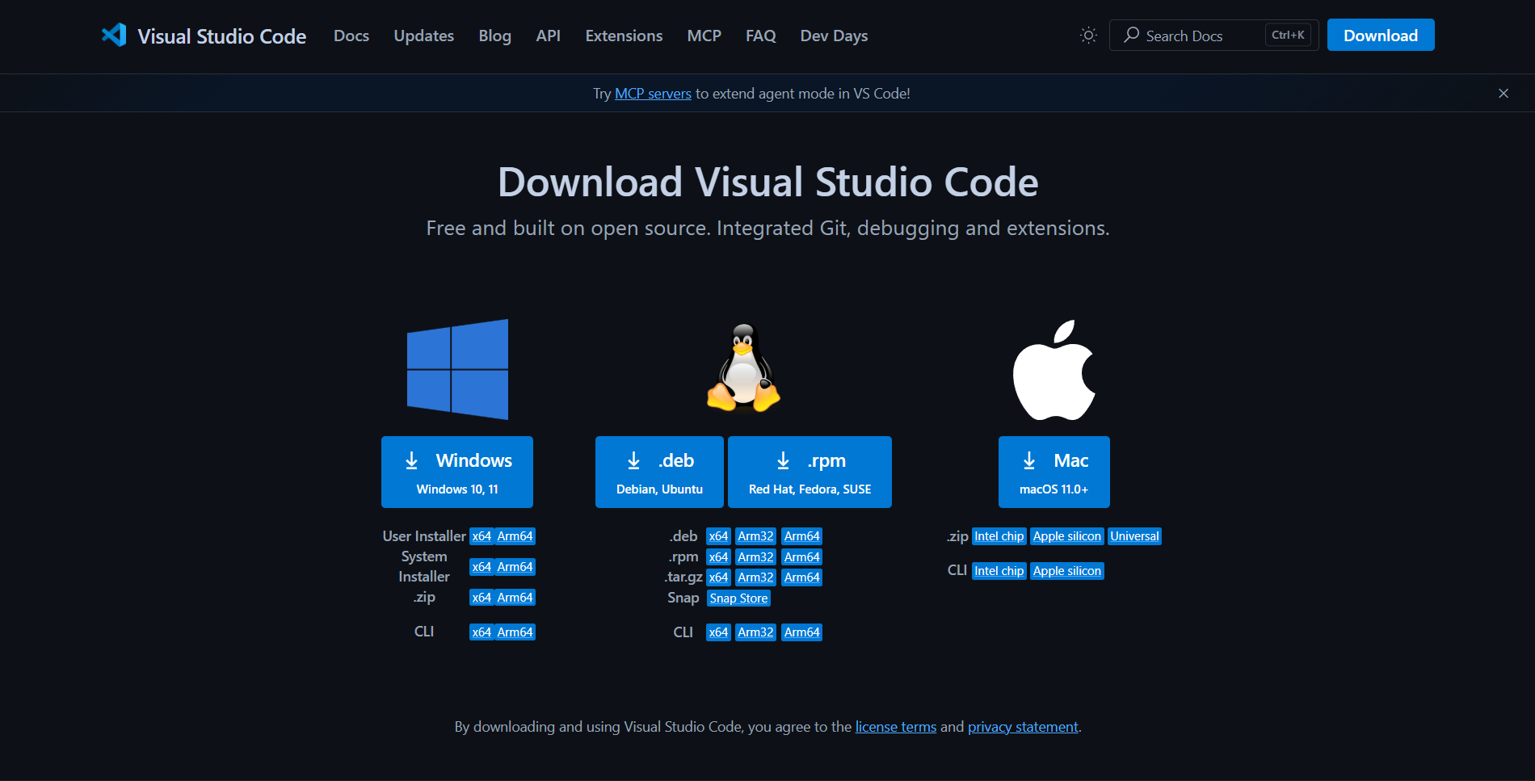

- Install Node.js (includes NPM)

Angular requires Node.js NPM is bundled with it. Get the LTS version from:
https://nodejs.org/en/download/package-manager
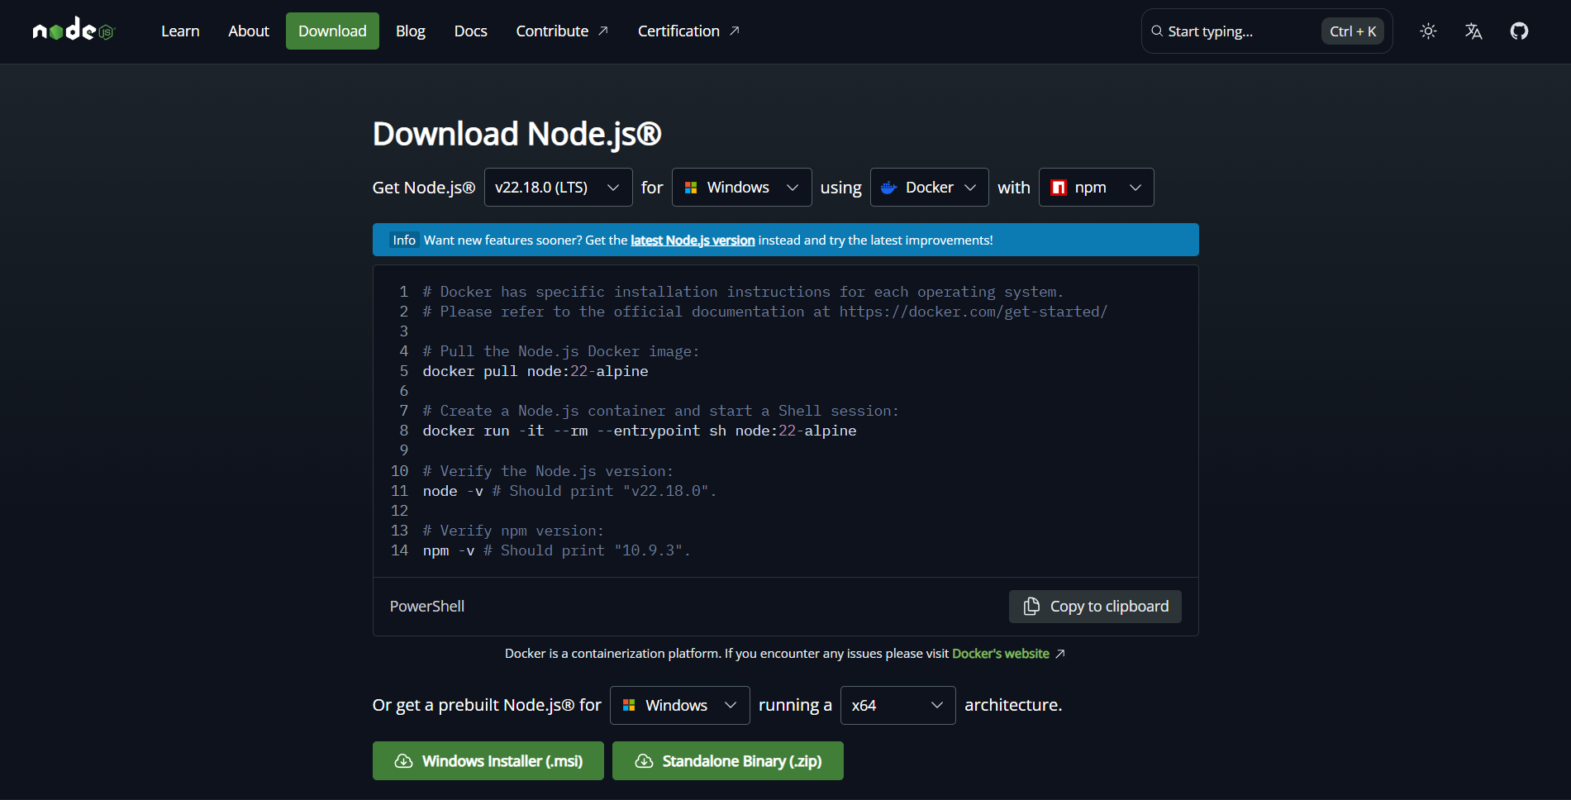

- Open the project in VS Code
Launch VS Code and open the project folder via File → Open Folder (Windows/Linux) or File → Open (macOS). You can also run code . from the project folder

- Open a terminal and navigate to the project path
In VS Code, open the integrated terminal (Terminal → New Terminal) and make sure you’re at the project’s root path (where package.json lives). Use cd your/project/path to get there.

- Install project dependencies
From the project root, run npm install to download (Node Package Manager) all dependencies listed in package.json. This step may take a few minutes the first time. NPM install reference.

- Start the development server
For start the project use npm start command in the terminal. Note that this command is run after the installing npm.
by default the app is run at http://localhost:4200/

Verify its running:
Open your browser and go to http://localhost:4200/ to see the application. If it doesn’t load, check the terminal for errors and fix any missing peer dependencies or type errors reported during the build.

Stop and rerun as needed:
To stop the dev server, focus the terminal window and press Ctrl + C (Windows/Linux/macOS). Restart anytime with npm start

